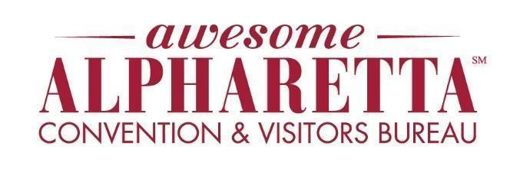

Peach State Steak Cookoff Debuts in Alpharetta
City of Alpharetta to host nationally known Bama-Q production on April 25

Alpharetta, GA – March 18, 2026 – Backyard steak lovers are in for a treat when the Peach State Steak Cookoff comes to Alpharetta on Saturday, April 25. The steak competition will sizzle in the parking lot of the newly refurbished Urban Hardware from 10 a.m. to 7 p.m., as more than 30 grill masters from across the Southeast fire up top steak, ribs, and peach- and peanut-inspired creations in a free, family-friendly event.
Part of a multi-city grilling challenge series organized by Bama-Q TV, the Peach State Steak Cookoff will feature seasoned cook teams, certified judges and multiple rounds of competition. The high-energy showdown will be filmed on-site for the Bama-Q television show, which airs on YouTube, Facebook, Roku TV and The Family Channel.
“The Peach State Steak Cookoff is a perfect fit for Alpharetta’s vibrant culinary scene and our lineup of spring events,” said Janet Rodgers, Alpharetta Convention & Visitors Bureau President and CEO. “We’re excited to welcome a competition of this caliber to our city and give residents and visitors a fun way to spend a Saturday in Alpharetta.”
Throughout the day, guests can watch pros prep and cook steaks, enjoy live music and take part in giveaways from event partners. Attendees can also pick up grilling tips and insider tricks during two live demonstration sessions with Bama-Q pro-staffers and B&B Pitmasters: from 11:30 a.m. to 12:30 p.m., Melvin Graham will showcase “Grilled Chicken Wings,” followed by a “Backyard Steak” demo with local pitmaster Bruce Johnson from 2:00 p.m. to 3:00 p.m.
“Alpharetta offers the perfect backdrop for our Peach State Steak Cookoff because of its notable food culture and welcoming community,” said Mike Smith, organizer with Bama-Q Production. “It’s a great opportunity for visitors to see some of the nation’s top 10 steak cooks in action and experience the excitement we share with fans through Bama-Q TV.”
For more information about the Peach State Steak Cookoff and competitor and judging registration, visit steakcookoffs.com/event-6551541. To explore more things to do, places to dine – including 10 steakhouses in the city – and where to stay in Alpharetta, go to AwesomeAlpharetta.com.
##

Event details at a glance
Event: Peach State Steak Cookoff
Date: Saturday, April 25, 2026
Time: 10 a.m. – 7 p.m.
Location: Urban Hardware, 11770 Haynes Bridge Rd., Alpharetta, GA 30022
Admission: Free to attend

Alpharetta Convention & Visitors Bureau
The Alpharetta Convention & Visitors Bureau serves as the official destination marketing organization for Alpharetta, Georgia, a thriving Southern city known for its dynamic culinary scene, premier shopping, family-friendly events and year-round entertainment. The Bureau promotes travel and tourism to increase economic impact and enhance the community’s quality of life by welcoming visitors to experience more than 200 dining options and an exciting lineup of annual festivals, concerts and outdoor recreation opportunities. Alpharetta offers 31 modern hotels, providing visitors with a wide range of lodging options. To learn more and book a stay, visit awesomealpharetta.com.

Media Contact:
Melissa Holder
Director of Public Relations & Communications, Alpharetta Convention and Visitors Bureau
Phone: 678-297-2811
Email: melissa@awesomealpharetta.com

