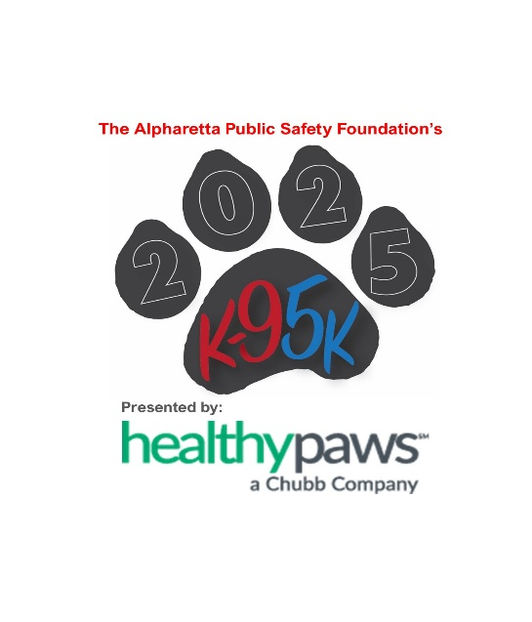

# **ALPHARETTA PUBLIC SAFETY FOUNDATION ANNOUNCES 2025 K9 5K FEATURING K9 MAVERICK – SUPPORTING LOCAL HEROES AND QUALIFYING FOR THE PEACHTREE ROAD RACE**

**OFFICIAL MEDIA RELEASE**

**For Immediate Release   
May 13, 2025**

The Alpharetta Public Safety Foundation (APSF) is thrilled to announce the return of its highly anticipated **K9 5K**, scheduled for **Saturday, June 14, 2025**, at **Dave & Buster's, 6500 North Point Pkwy, Alpharetta, GA**. This community-driven event not only supports local first responders and their families but also serves as a **qualifier for the iconic Peachtree Road Race**. Runners and walkers of all ages are invited to join the excitement, with the fast, flat course along **North Point Parkway** offering a perfect opportunity to achieve personal bests.

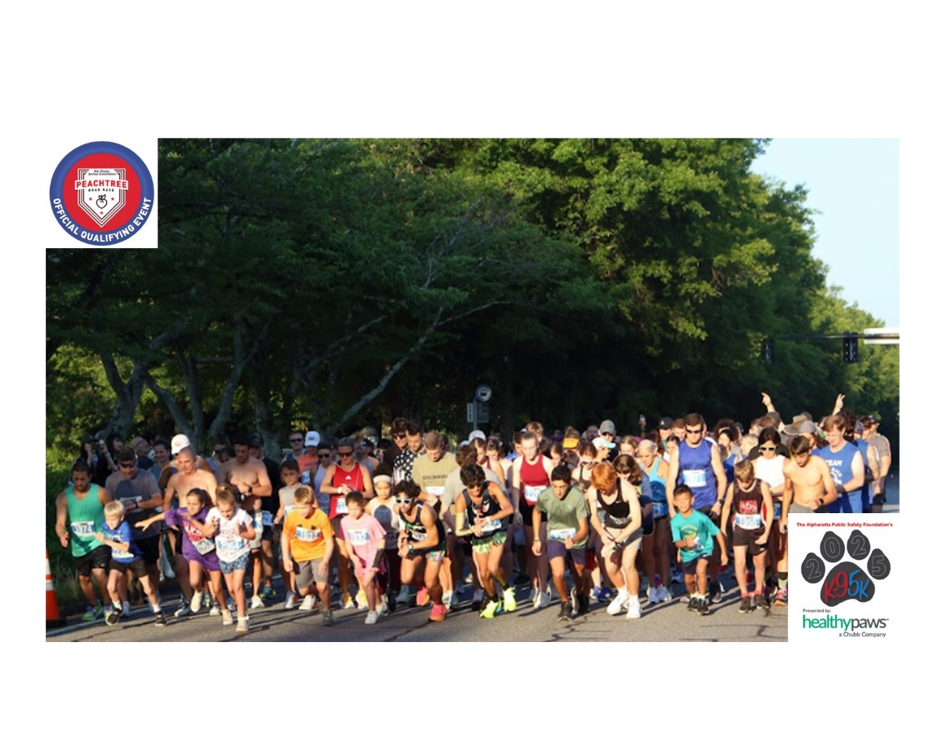

This year’s race proudly features **K9 Maverick**, a three-year-old German Shepherd/Belgian Malinois mix who has been a vital member of the Alpharetta Police Department for over two years. Alongside Officer Jahnke, Maverick has specialized in narcotics detection, evidence recovery, and suspect apprehension, contributing to the capture of multiple suspects and the seizure of over five kilograms of narcotics. Maverick’s dedication and sharp instincts have solidified his role as a local hero, and this year, he is honored as the face of the **2025 K9 5K T-shirt**. The exclusive shirt, unveiled during the **Alpharetta Business Association’s Business Afterhours** at **Summerfield Mortgage LLC**, is available only to race participants, making it a special keepsake for those who run or walk in support of public safety.

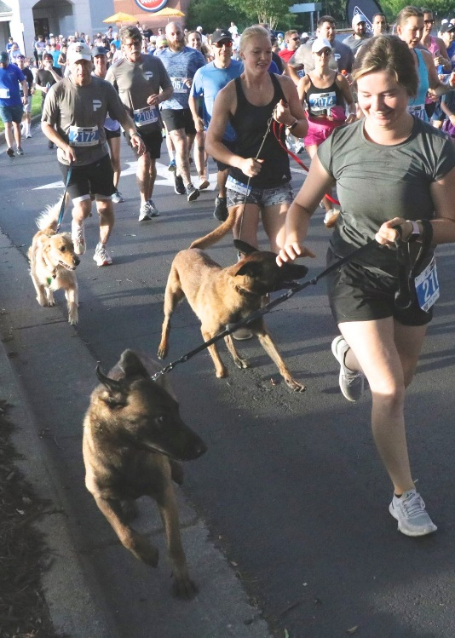 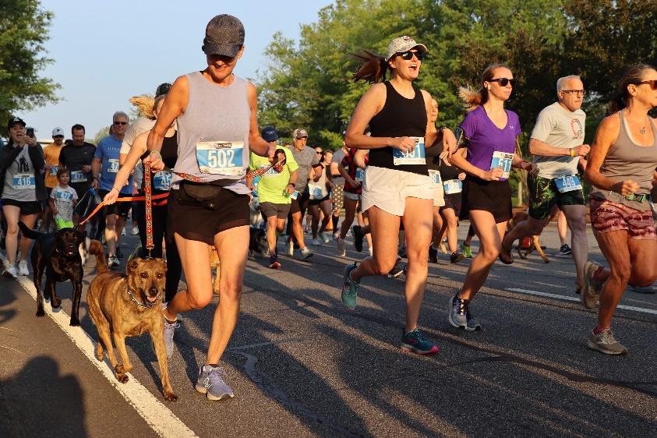

The Alpharetta Public Safety Foundation is proud to welcome **Healthy Paws Pet Insurance** **as the Presenting Sponsor** for the 2025 K9 5K. Healthy Paws, a leader in pet health and wellness since 2009, has helped countless pet parents provide advanced medical care for their four-legged family members. “We are thrilled to be the Premier Sponsor of this year’s K9 5K. At Healthy Paws, we believe that the bond between pets and their families is unbreakable and supporting events like this allows us to give back to the community and celebrate the incredible contributions of service animals like K9 Maverick,” said Alex Faynberg, EVP, Head of Healthy Paws Pet Insurance. “This partnership with APSF aligns perfectly with our mission to help pets live longer, healthier lives, and we are proud to support the heroes that protect Alpharetta every day.”

Adding to the enthusiasm, **Jamie Pennington, Chairman of the Board for the Alpharetta Public Safety Foundation**, shared her thoughts on the impact of the K9 5K: *“The K9 5K is more than just a race—it’s a celebration of community spirit and unwavering support for the brave men and women who protect us daily. Seeing families, friends, and local businesses come together for such an important cause is a testament to the strength and unity of Alpharetta. We are proud to host this event and deeply grateful for the community’s continued support.”*

**Joe Wargo, APSF Board Member and K9 5K Race Director** expressed his excitement for this year’s race. “This event is truly special—not only does it support our local first responders, but it also brings the community together in a meaningful way. As a long-time supporter of APSF, I am honored to help coordinate this year’s race.”

Proceeds from the K9 5K directly benefit the **Alpharetta Public Safety Foundation**, a 501(c)(3) nonprofit organization dedicated to supporting police, fire, communications, and civilian personnel within the Alpharetta Department of Public Safety. Funds raised help provide **critical equipment, advanced training, and community safety programs** like CPR training and car seat installations, as well as **disaster relief education**. Importantly, the Foundation also focuses on **supporting the health and well-being of our public safety personnel during their times of need**, ensuring that those who protect our community receive the care and assistance they deserve. By participating in the race, community members are not only contributing to public safety initiatives but also standing behind the brave men and women who protect Alpharetta every day.

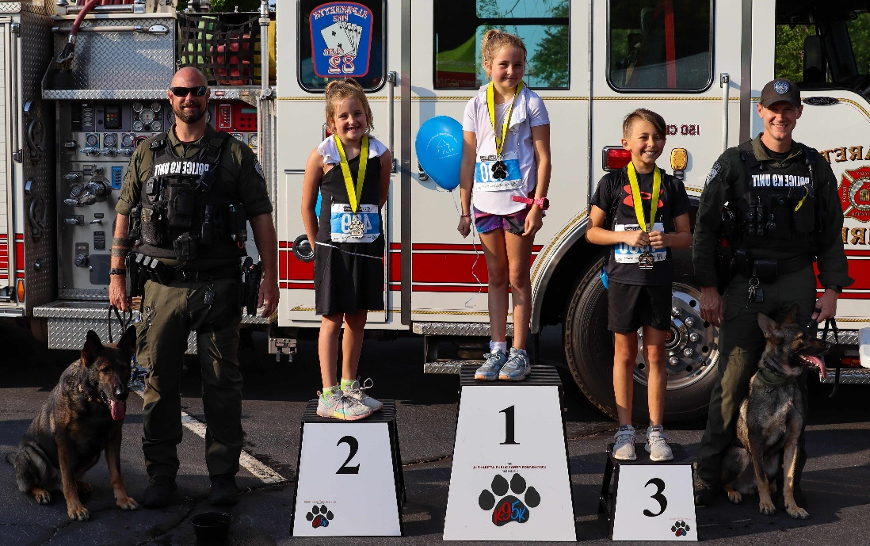

To get race-ready, community members are encouraged to join **Project Lean Nation** and **The Strong Run Coach Betsy** for **free weekly training sessions**. These meetups take place on **Wednesdays at 6 PM** with hydration mix, shake samples, and storewide discounts, and **Thursdays at 6:30 PM** at **Summerfield Mortgage near Rock Mill Park** with **Coach Rebecca Douglas**. All fitness levels are welcome—bring friends, family, and even your four-legged companions for a fun and supportive training experience.

Registration for the 2025 K9 5K is now open, with limited spots available. Participants will secure their exclusive **K9 Maverick T-shirt** upon registration. Visit [**www.alphak9-5k.com**](http://www.alphak9-5k.com/) to sign up and join this powerful community event that strengthens public safety and supports those who serve.

##

**About the Alpharetta Public Safety Foundation:**  
The Alpharetta Public Safety Foundation (APSF) is a 501(c)(3) nonprofit organization committed to enhancing public safety in Alpharetta. Through donations and sponsorships, the Foundation funds essential training, equipment, and community safety programs. APSF is dedicated to ensuring that Alpharetta remains a safe and thriving community for all who live, work, and visit.

**Contact Information:**  
Joe Wargo, Race Director   
Alpharetta Public Safety Foundation  
Owner/Broker of Summerfield Mortgage LLC  
Phone: 678-557-1329  
Email: [jwargo@summefieldmortgage.com](mailto:jwargo@summefieldmortgage.com)